Running Lab 4 patterns from Pycharm:

In order to run all patterns directly from pycharm, without having to type the commands in the instructions on the command line of a terminal, you need to create/edit the run configuration of your program as follows:

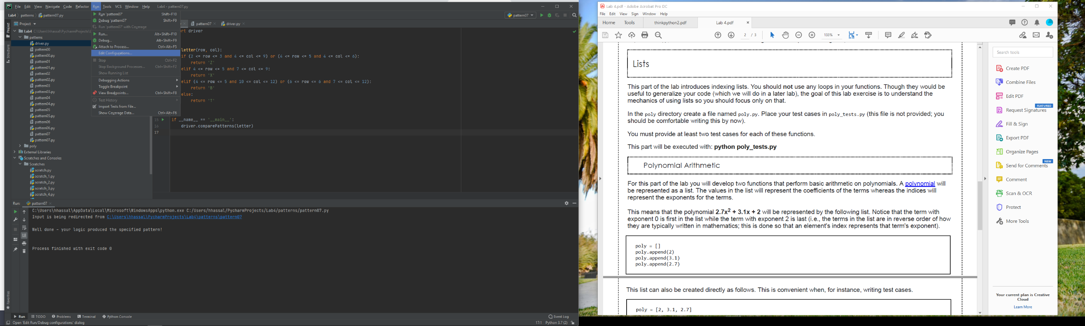After finishing each part, go the ‘run’ menu and select ‘Edit Configurations’

Create a new configuration of each part (i.e. patternXX.py) and name it with a different name (top red box). You can just copy the first configuration as many times as needed, and adjust the values on each one.

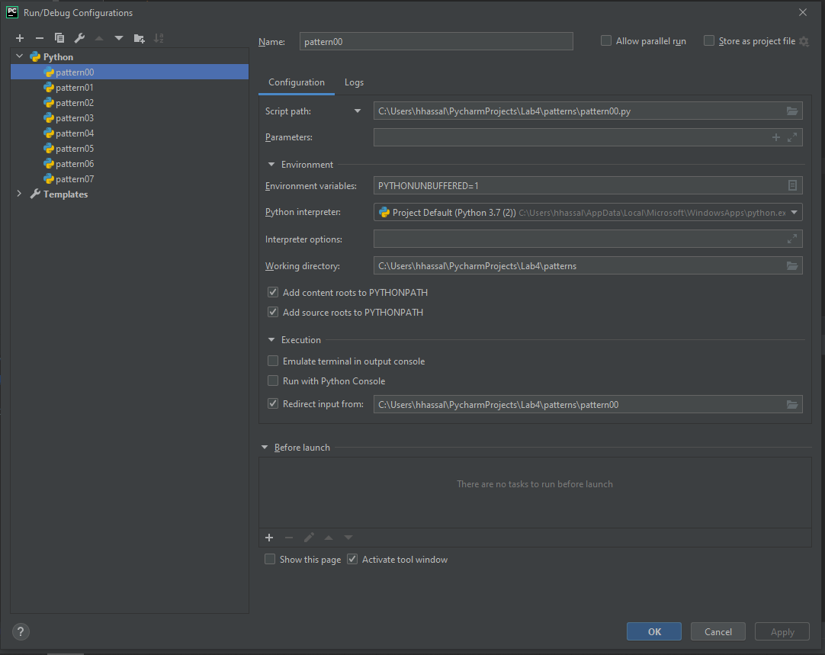

Copy config.

In the ‘*Script path’* (second red box), make sure the name of the script is correct (e.g. pattern01.py)

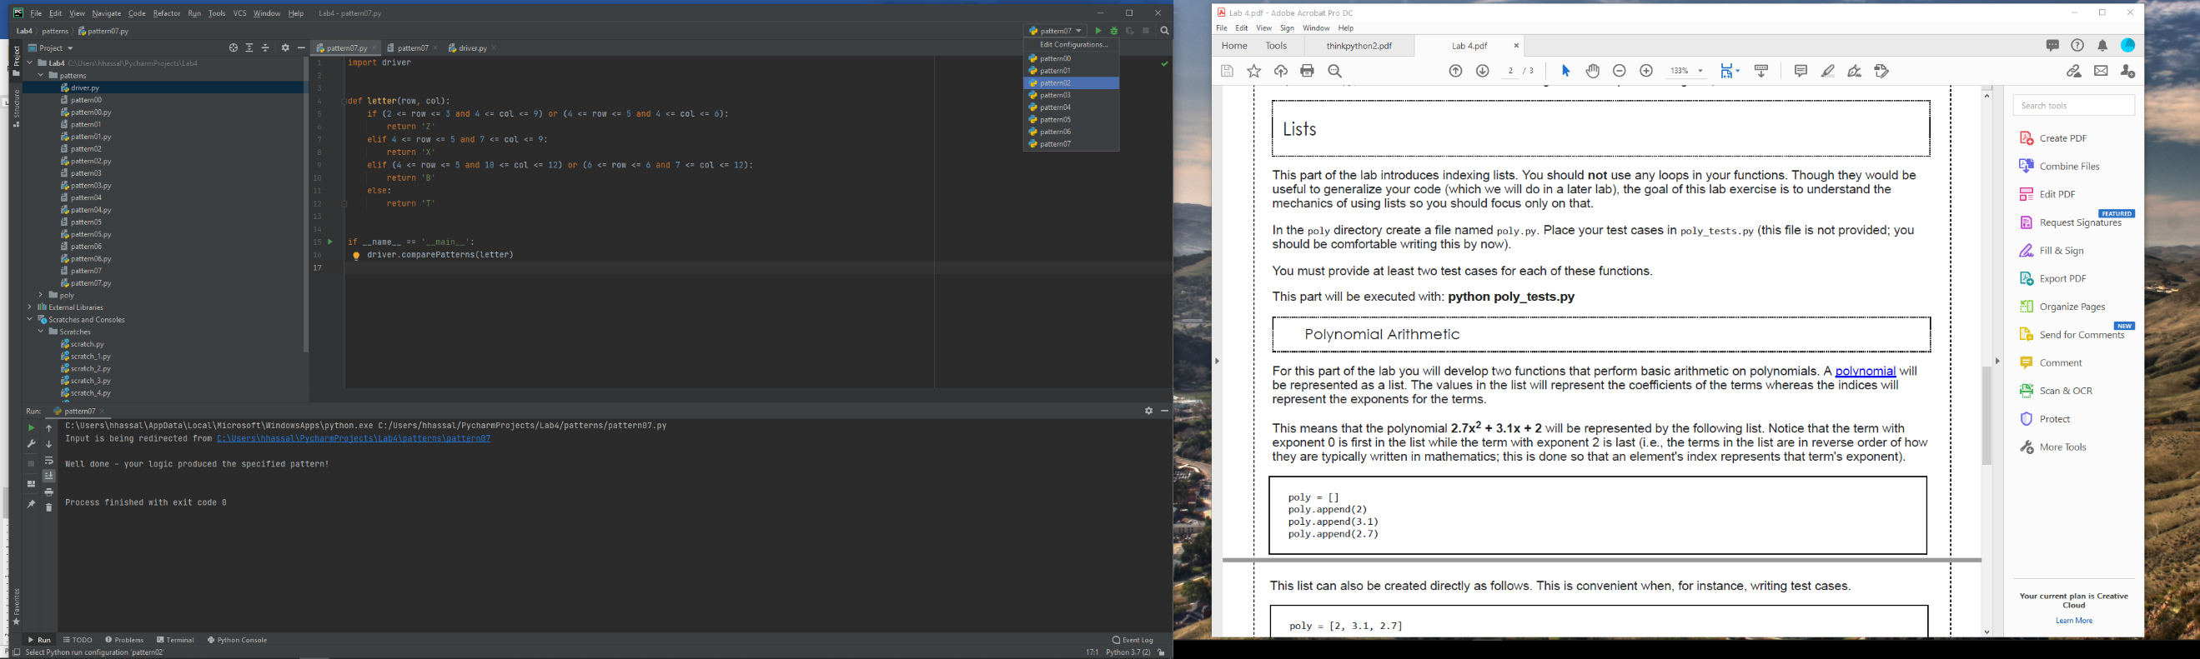Under the ‘Execution’ section, check the ‘*Redirect input from*:‘ checkbox and add the pattern file name in box (third red box). You can select the file by clicking the folder icon to the left.

After you’ve created all the configs, they will appear in a drop down next to the run button. Select the config you want and run it.